# Tables, Figures and Numbers

## Table 2 Topic Summary

### 1.1 Top 10 words in each topic

*Topic 1 Top Words:*

*Highest Prob: rioter, station, set, fire, vandal, damag, road, mtr, sunday, block*

*FREX: vandal, mtr, block, facil, barricad, rampag, metro, kok, mong, hom*

*Lift: cross-harbour, arsonist, ash, barricad, bin, black-shirt, burst, buse, carriag, carriageway*

*Score: rioter, station, vandal, mtr, fire, road, set, barricad, block, black-clad*

*Topic 2 Top Words:*

*Highest Prob: law, rule, western, opinion, expert, anti-mask, media, stand, freedom, court*

*FREX: rule, western, opinion, anti-mask, standard, doubl, enact, law, freedom, stand*

*Lift: fighter, media’, rhetor, ‘creates’, “freedom, anarchi, anonym, anti-mask, aspect, candl*

*Score: law, rule, anti-mask, western, opinion, doubl, standard, freedom, court, basic*

*Topic 3 Top Words:*

*Highest Prob: live, press, hold, confer, daili, news, latest, brief, via, west*

*FREX: live, press, hold, confer, brief, west, fake, high-spe, lai, jimmi*

*Lift: chee-i, fake, gift, ka-chuen, lan, lawsuit, minion, regular, southwest, stapl*

*Score: press, live, confer, hold, brief, high-spe, news, daili, west, train*

*Topic 4 Top Words:*

*Highest Prob: chief, lam, execut, carri, region, administr, special, govern, sar, said*

*FREX: chief, lam, execut, carri, region, special, dialogu, yuet-ngor, administr, sar*

*Lift: affirm, badly-hit, buffet, carri, chee-hwa, compromis, defici, dialogu, exec, han*

*Score: lam, chief, execut, carri, administr, special, region, dialogu, yuet-ngor, cheng*

*Topic 5 Top Words:*

*Highest Prob: bank, billion, measur, hit, million, enter, announc, help, head, total*

*FREX: bank, billion, pay, die, relief, victim, price, worth, cleaner, unveil*

*Lift: “’re, bours, burden, cap, cash, certif, cleaner, dollar-denomin, environment, formul*

*Score: billion, bank, yuan, dollar, relief, million, list, pay, die, cleaner*

*Topic 6 Top Words:*

*Highest Prob: photo, can, make, mani, becom, now, want, like, major, see*

*FREX: want, just, dont, observ, vcg, photo, ruin, afp, troubl, can*

*Lift: dilemma, homeland, satisfi, afp, angelo, backer, beacon, belief, bet, childhood*

*Score: photo, can, want, make, like, mani, becom, now, dont, ruin*

*Topic 7 Top Words:*

*Highest Prob: peopl, univers, student, young, campus, former, polytechn, among, made, leung*

*FREX: univers, campus, polytechn, leung, polyu, defend, color, revolut, standoff, chun-i*

*Lift: anxieti, battleground, campus, chun-i, color, cuhk, defend, freeman, leung, persuad*

*Score: univers, peopl, student, campus, young, polytechn, former, leung, polyu, studi*

*Topic 8 Top Words:*

*Highest Prob: nation, chines, flag, held, celebr, peopl, anniversari, china, love, day*

*FREX: flag, celebr, anniversari, patriot, anthem, ceremoni, sing, republ, wave, song*

*Lift: allur, anniversari, anthem, bigham, boast, ceremoni, championship, commemor, danc, flag*

*Score: nation, flag, celebr, anniversari, anthem, republ, ceremoni, sing, love, held*

*Topic 9 Top Words:*

*Highest Prob: countri, one, two, system, stabil, principl, prosper, challeng, safeguard, interest*

*FREX: system, principl, prosper, interest, posit, “one, systems”, core, advantag, long-term*

*Lift: ‘one, advantag, blunt, bottom-lin, core, country”, davo, delta, einar, factual*

*Score: countri, system, two, principl, one, prosper, stabil, systems”, interest, “one*

*Topic 10 Top Words:*

*Highest Prob: violenc, say, order, restor, escal, citizen, social, must, crime, task*

*FREX: violenc, restor, silent, say, escal, crime, order, task, lamppost, fight*

*Lift: alik, gloss, heartbroken”, indeped, rapper, silent, spill, spoken, violenc, restor*

*Score: violenc, restor, order, say, escal, task, silent, must, prioriti, urgent*

*Topic 11 Top Words:*

*Highest Prob: develop, macao, area, bay, greater, will, guangdong, futur, econom, plan*

*FREX: develop, greater, opportun, problem, innov, entrepreneur, talent, jacqu, martin, estat*

*Lift: afford, area’, backdrop, belt, boom, bright, chi-, complementari, destini, dream*

*Score: greater, develop, bay, area, guangdong, opportun, macao, econom, futur, hous*

*Topic 12 Top Words:*

*Highest Prob: educ, toward, home, xinhua, children, matter, punish, school, handl, eye*

*FREX: educ, xinhua, punish, eye, bureau, parent, blame, everyon, exampl, evil*

*Lift: classroom, eye, outnumb, sometim, yun-hung, ambigu, analys, bite, blind, bought*

*Score: educ, children, toward, home, teacher, xinhua, eye, school, matter, bureau*

*Topic 13 Top Words:*

*Highest Prob: behind, happen, interview, media, truth, chan, tell, tri, taiwan, lee*

*FREX: behind, truth, tell, exclus, reveal, surrend, true, wife, pansi, tong-kai*

*Lift: anim, atroc, chun-chung, context, forev, freeli, hsien, illustr, kyoto, loong*

*Score: happen, truth, interview, behind, exclus, lee, tell, tong-kai, taiwan, pansi*

*Topic 14 Top Words:*

*Highest Prob: protest, violent, radic, condemn, act, demonstr, strong, illeg, recent, sever*

*FREX: violent, protest, radic, protestor, demonstr, condemn, act, vandalist, journalist, commit*

*Lift: rundown, laser, rioters, beams, misplac, nab, overindulg, ptu, shone, slowli*

*Score: protest, violent, radic, condemn, act, illeg, demonstr, strong, protestor, journalist*

*Topic 15 Top Words:*

*Highest Prob: follow, statement, civil, compani, british, ask, issu, airlin, question, stanc*

*FREX: civil, airlin, employe, union, lose, cathay, draw, requir, servant, publish*

*Lift: airplan, bush, cabin, citizenship, confess, degener, elabor, fallaci, fence-sit, lancet*

*Score: airlin, cathay, employe, compani, civil, pacif, british, consul, aviat, stanc*

*Topic 16 Top Words:*

*Highest Prob: unrest, month, social, economi, financi, busi, amid, tourism, past, industri*

*FREX: unrest, month, economi, tourism, drop, prolong, retail, unemploy, financi, protract*

*Lift: abrupt, adjust, august-octob, blog, brunt, budget, consumpt, decad, default, deficit*

*Score: unrest, economi, financi, tourism, month, industri, percent, amid, busi, retail*

*Topic 17 Top Words:*

*Highest Prob: public, safeti, secur, concern, serious, activ, onlin, particip, member, other*

*FREX: public, other, threat, person, pose, petit, restraint, edward, safeti, princ*

*Lift: ll, accompani, alumni, demean, edward, finest, privaci, qianhai, rumour, other*

*Score: public, safeti, onlin, secur, serious, person, concern, threat, particip, inform*

*Topic 18 Top Words:*

*Highest Prob: will, end, situat, stop, chao, bring, back, hope, urg, come*

*FREX: situat, possibl, soon, end, back, chao, doom, bring, hope, come*

*Lift: disgrac, donaghi, dpp, guang, kezhi, patric, perri, tougher, unwav, xiaoguang*

*Score: end, stop, situat, chao, will, bring, back, soon, extern, hope*

*Topic 19 Top Words:*

*Highest Prob: airport, day, intern, monday, disrupt, oper, cancel, flight, passeng, school*

*FREX: airport, cancel, flight, injunct, resum, strike, disrupt, interim, passeng, class*

*Lift: airport’, break-, clog, hkia, interim, isol, partial, perish, premium, primari*

*Score: airport, flight, cancel, disrupt, injunct, passeng, intern, day, school, oper*

*Topic 20 Top Words:*

*Highest Prob: china, beij, case, world, visit, miss, provinc, bridg, top, south*

*FREX: miss, bridg, sanction, zhuhai-macao, entri, ngos, ship, border, zhuhai, negoti*

*Lift: adjac, anti-terror, calcul, carbon, checkpoint, china-russia, cross-sea, earthquak, fedex, first-class*

*Score: china, miss, case, bridg, beij, provinc, visit, zhuhai-macao, south, sanction*

*Topic 21 Top Words:*

*Highest Prob: report, attack, legisl, man, justic, lawmak, media, time, investig, junius*

*FREX: man, justic, investig, junius, hospit, mun, tuen, knife, stab, kwan-yiu*

*Lift: -duti, assassin, chest, guohao, adjourn, arent, bail, besid, blade, chu*

*Score: man, report, attack, legisl, junius, hospit, justic, lawmak, knife, tuen*

*Topic 22 Top Words:*

*Highest Prob: call, peac, polit, societi, use, differ, way, appeal, life, view*

*FREX: call, peac, view, keep, ration, calm, spirit, life, societi, excess*

*Lift: calm, incess, perspect, preserv, prosecutor, ration, rift, rocki, suppress, tangl*

*Score: call, peac, polit, societi, appeal, differ, way, ration, life, view*

*Topic 23 Top Words:*

*Highest Prob: council, district, elect, wong, vote, ordinari, sunday, poll, joshua, councilor*

*FREX: council, elect, wong, vote, poll, joshua, candid, voter, turnout, district*

*Lift: agn, boundari, brazen, consulate-gener, ear, elector, joshua, lok, loom, nixi*

*Score: elect, council, district, vote, voter, candid, poll, turnout, wong, joshua*

*Topic 24 Top Words:*

*Highest Prob: mainland, new, chines, year, number, tourist, start, open, will, market*

*FREX: mainland, tourist, chen, qingqinggt, popular, holiday, new, cultur, york, year*

*Lift: cultur, york, 🇨🇳🇭🇰❤️, academi, babi, baidu, batch, carniv, cement, chen*

*Score: mainland, new, year, chines, tourist, number, film, market, holiday, million*

*Topic 25 Top Words:*

*Highest Prob: polic, offic, arrest, rioter, bomb, attack, use, petrol, assembl, sunday*

*FREX: bomb, petrol, weapon, shot, explos, gun, dispers, possess, men, femal*

*Lift: acid, ammunit, chemic, disastr, imit, outfit, rubber, self, steel, airsoft*

*Score: polic, bomb, arrest, petrol, offic, weapon, attack, injur, assault, assembl*

*Topic 26 Top Words:*

*Highest Prob: china, affair, foreign, right, chines, act, intern, human, spokesperson, ministri*

*FREX: affair, foreign, ministri, interfer, remark, pass, senat, meddl, legislatur, democraci*

*Lift: american-styl, baffl, bare-fac, china-smear, confound, congressional-execut, congressman, consul-gener, eliot, engel*

*Score: affair, foreign, interfer, ministri, human, china, right, democraci, spokesperson, remark*

*Topic 27 Top Words:*

*Highest Prob: polic, support, resid, forc, riot, show, ralli, saturday, video, group*

*FREX: ralli, enforc, support, riot, havoc, forc, show, deal, action, resid*

*Lift: chi-wai, clinton, iraq, man-tak, sacrific, sting, thank-, wai-kei, wilki, safeguard*

*Score: support, polic, ralli, resid, riot, forc, enforc, show, saturday, voic*

*Topic 28 Top Words:*

*Highest Prob: chines, china, part, netizen, ambassador, general, critic, apolog, fan, separatist*

*FREX: netizen, ambassador, apolog, fan, xiaom, summon, lodg, secessionist, brand, websit*

*Lift: doubl, amazon, assur, bhattarai, brand, cba, china-uk, cohen, daffair, drink*

*Score: ambassador, chines, summon, represent, netizen, lodg, xiaom, general, liu, fan*

*Topic 29 Top Words:*

*Highest Prob: govern, central, govt, offic, liaison, garrison, peopl, protect, pla, respect*

*FREX: liaison, garrison, pla, armi, luo, huin, appoint, rotat, govt, central*

*Lift: appoint, devot, hin-chi, impermiss, maria, neo-nazi, ngong, relic, shuen, statu*

*Score: central, liaison, garrison, govern, govt, pla, offic, huin, armi, luo*

*Topic 30 Top Words:*

*Highest Prob: citi, said, take, offici, time, also, respons, still, senior, messag*

*FREX: citi, take, respons, offici, said, also, senior, messag, still, time*

*Lift: ransom, take, citi, tough, messag, senior, also, still, respons, offici*

*Score: citi, take, said, offici, time, senior, also, respons, still, messag*

### Percentage of each topic

*topic proportion*

*1 0.05964859*

*2 0.03740530*

*3 0.02053179*

*4 0.05569098*

*5 0.02473432*

*6 0.03211145*

*7 0.02558520*

*8 0.03690483*

*9 0.02839825*

*10 0.03160781*

*11 0.03151509*

*12 0.01655542*

*13 0.02669478*

*14 0.04376469*

*15 0.02012684*

*16 0.04567861*

*17 0.02133654*

*18 0.03306988*

*19 0.02953046*

*20 0.02856601*

*21 0.03440083*

*22 0.02478362*

*23 0.02027625*

*24 0.02702939*

*25 0.06751842*

*26 0.06921263*

*27 0.03891393*

*28 0.02519502*

*29 0.02675791*

*30 0.01645515*

## 2. Figure 2 Trends of all tweets

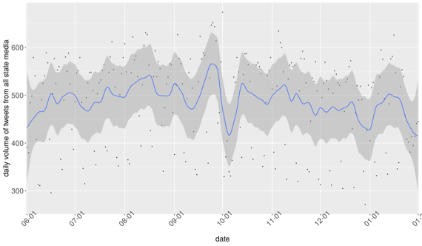

## 3. Figure 3 Temporal trends of the 30 topics identified from all tweets

## 

## 4. Figure 4 Differences in topical prevalence

### 4.1 Topic diff in ranking

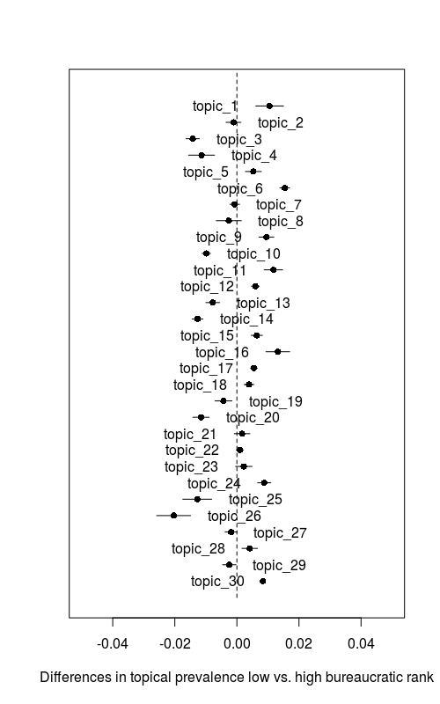

### 4.2 Topic diff in engagement

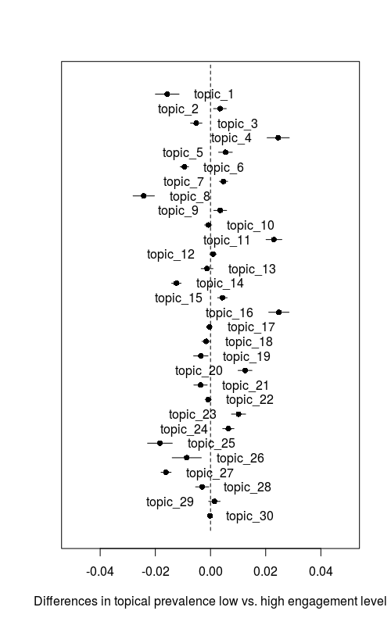

## 5. topics & terms by proportion

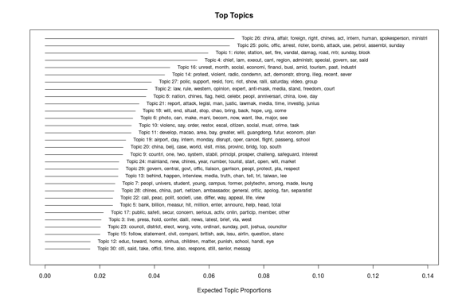

## 6. topic cooccurrence network

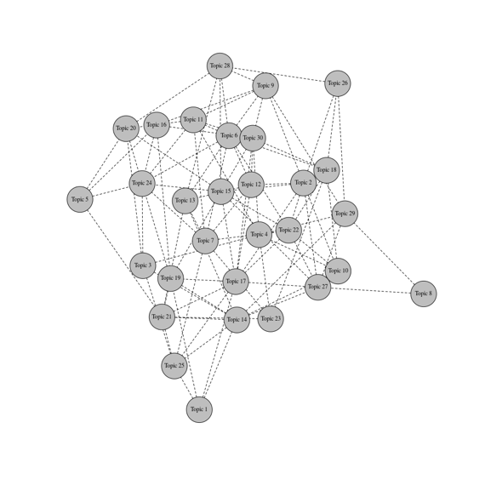

## 7. Confidence Intervals [CI] of topic difference

### 7.1 Ranking

*[[1]]*

*[1] 0.006088921 0.015006764*

*[[2]]*

*[1] -0.003484924 0.001310343*

*[[3]]*

*[1] -0.01638029 -0.01208901*

*[[4]]*

*[1] -0.015568449 -0.007183522*

*[[5]]*

*[1] 0.002712449 0.007871884*

*[[6]]*

*[1] 0.01385020 0.01697054*

*[[7]]*

*[1] -0.0022669486 0.0008537742*

*[[8]]*

*[1] -0.006647172 0.001419683*

*[[9]]*

*[1] 0.00709472 0.01191242*

*[[10]]*

*[1] -0.011190673 -0.008503319*

*[[11]]*

*[1] 0.008768833 0.014763398*

*[[12]]*

*[1] 0.004676338 0.007219653*

*[[13]]*

*[1] -0.009988239 -0.005561690*

*[[14]]*

*[1] -0.01443463 -0.01090333*

*[[15]]*

*[1] 0.004613348 0.008217843*

*[[16]]*

*[1] 0.009352517 0.017022940*

*[[17]]*

*[1] 0.004381233 0.006581331*

*[[18]]*

*[1] 0.002329115 0.005507477*

*[[19]]*

*[1] -0.007028287 -0.001601357*

*[[20]]*

*[1] -0.014175080 -0.008952535*

*[[21]]*

*[1] -0.0008511628 0.0041780697*

*[[22]]*

*[1] -0.0001973157 0.0021268268*

*[[23]]*

*[1] -0.000455786 0.004869049*

*[[24]]*

*[1] 0.006683933 0.010928069*

*[[25]]*

*[1] -0.017426528 -0.008105581*

*[[26]]*

*[1] -0.02583586 -0.01491364*

*[[27]]*

*[1] -0.00379207223 0.00002272811*

*[[28]]*

*[1] 0.001658393 0.006648187*

*[[29]]*

*[1] -0.0045802802 -0.0002860425*

*[[30]]*

*[1] 0.008025296 0.008737440*

### 7.2 Engagement

*[[1]]*

*[1] -0.01998932 -0.01140135*

*[[2]]*

*[1] 0.001097481 0.005719396*

*[[3]]*

*[1] -0.007249190 -0.003088279*

*[[4]]*

*[1] 0.02051403 0.02856215*

*[[5]]*

*[1] 0.002930489 0.007904484*

*[[6]]*

*[1] -0.010993674 -0.007959059*

*[[7]]*

*[1] 0.003206085 0.006210525*

*[[8]]*

*[1] -0.02807232 -0.02033993*

*[[9]]*

*[1] 0.001178821 0.005833053*

*[[10]]*

*[1] -0.0021511977 0.0004605457*

*[[11]]*

*[1] 0.02013548 0.02587303*

*[[12]]*

*[1] -0.000301792 0.002158188*

*[[13]]*

*[1] -0.0033741112 0.0009014165*

*[[14]]*

*[1] -0.01407952 -0.01067559*

*[[15]]*

*[1] 0.002564883 0.006043536*

*[[16]]*

*[1] 0.02110728 0.02846553*

*[[17]]*

*[1] -0.0014391375 0.0006899569*

*[[18]]*

*[1] -0.003097627 -0.000030923*

*[[19]]*

*[1] -0.0061319573 -0.0008990876*

*[[20]]*

*[1] 0.01000015 0.01503151*

*[[21]]*

*[1] -0.006042922 -0.001195369*

*[[22]]*

*[1] -0.0019574311 0.0002834027*

*[[23]]*

*[1] 0.007607291 0.012729507*

*[[24]]*

*[1] 0.004415094 0.008511491*

*[[25]]*

*[1] -0.02282432 -0.01385009*

*[[26]]*

*[1] -0.013890984 -0.003342615*

*[[27]]*

*[1] -0.01792624 -0.01429058*

*[[28]]*

*[1] -0.0054163632 -0.0006046475*

*[[29]]*

*[1] -0.0006603449 0.0034803973*

*[[30]]*

*[1] -0.0005405342 0.0002012875*